Bug_id_01
Bug Description:
Unexpected logout occurs when using browser back button after successful login. Users get logged out and redirected to login page instead of staying authenticated within the application.
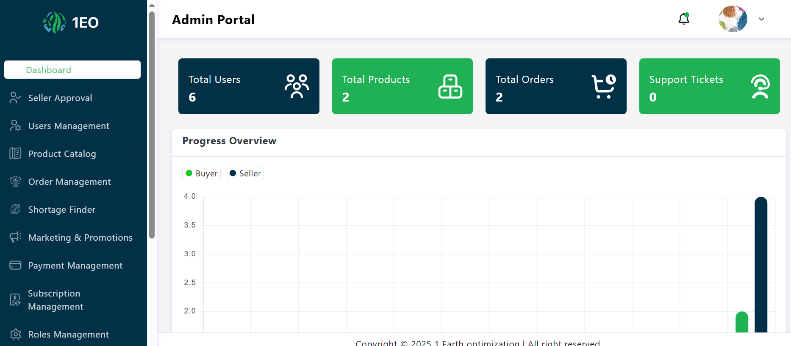
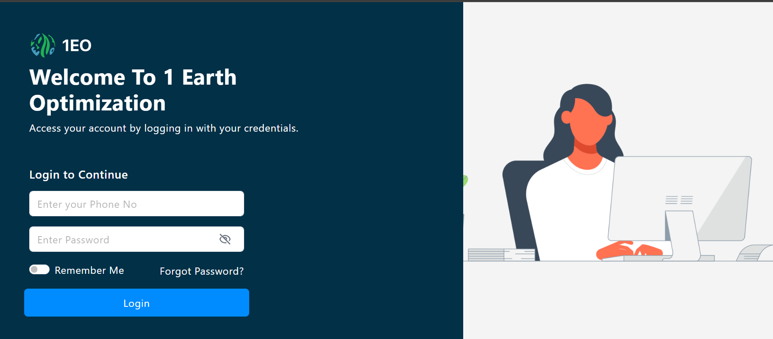

Reproduction Steps:
- Navigate to: https://admin.stg.1earthop.com/auth/signin
- Enter Phone: +11234567890
- Enter Password: admin123
- Click Login → Successfully reaches Admin Dashboard
- Click Browser Back Button (←) in browser toolbar
- Observe: Instead of returning to Dashboard, user is LOGGED OUT
- Redirected back to Login page

Bug_id_02
Bug Description:
Login attempt limit security feature is not functioning correctly. The system fails to block users or display warning messages after exceeding the allowed number of failed login attempts, allowing unlimited brute force attacks without security restrictions.
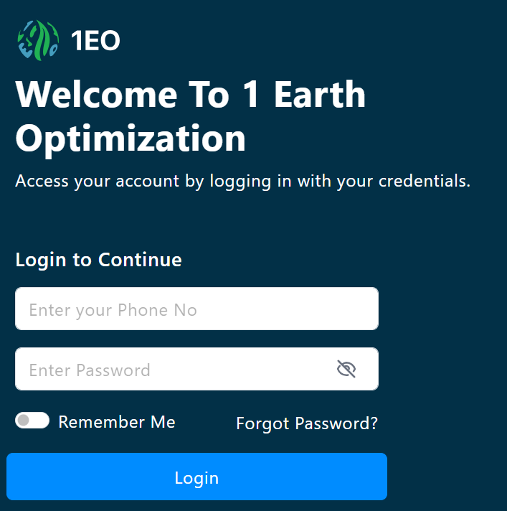
Bug_id_03
Bug Description:
Session timeout security feature is not functioning. Users remain logged in indefinitely even after 30+ minutes of inactivity, creating security vulnerability where unattended admin sessions can be accessed by unauthorized users.
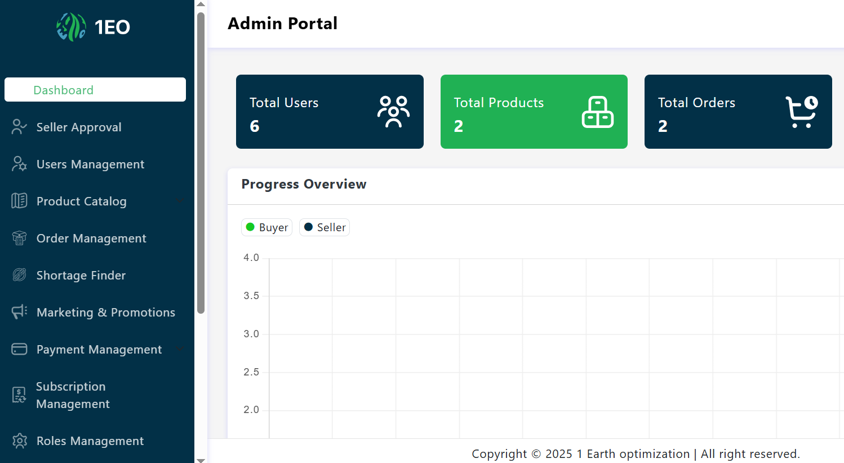

Reproduction Steps:
1. Navigate to: https://admin.stg.1earthop.com/auth/signin
2. Login with valid credentials (Phone: +11234567890, Password: admin123)
3. Successfully reach Admin Dashboard
4. Leave browser OPEN but INACTIVE for 31+ minutes
5. After 31 minutes, click any menu item or try to perform action
6. Observe: User remains logged in (should be logged out)
7. No redirect to login page occurs

Bug_id_04
Bug Description:
"Remember Me" functionality is completely broken. When users check "Remember Me" during login and close/reopen browser, they are not automatically logged in as expected, forcing manual credential entry every time despite the feature being selected.
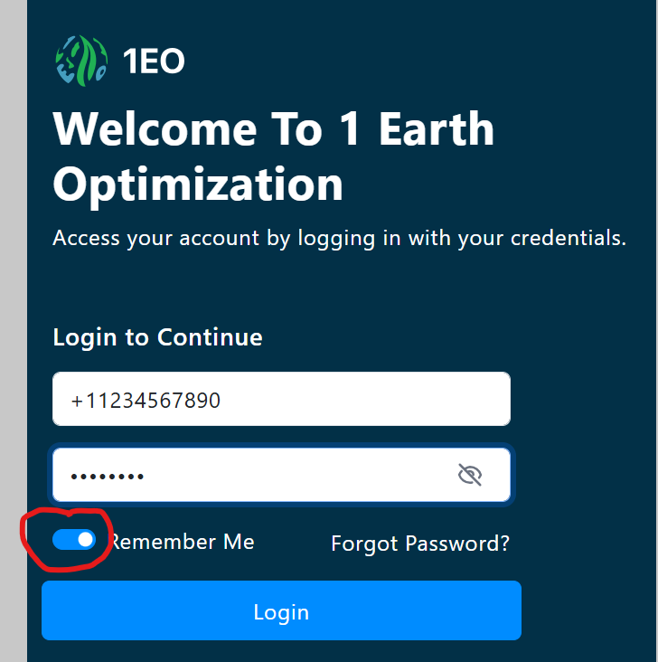

Bug_id_05
Bug Description:
UI layout becomes unstable and elements overlap when login is attempted with empty form fields. The heading/logo shifts position and overlaps with other page elements, breaking the visual design and creating an unprofessional appearance during error states.

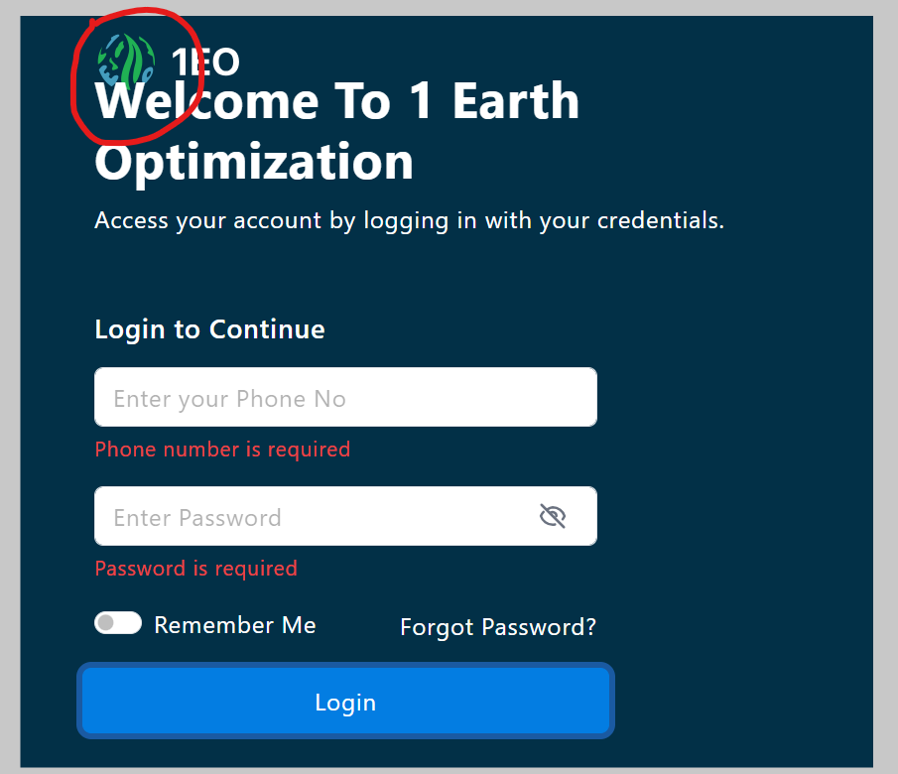

Bug_id_06
Bug Description:
Login button fails to provide visual feedback during user interactions. The button remains static with no hover effects, active states, or visual changes when clicked, making it difficult for users to perceive interactivity and reducing overall user experience.
